The PA KEI is a teacher-reported measure of child competencies at the start of kindergarten.

The PA KEI reports student progress for a subset of the PA Standards which includes 5 of the 8 Key Learning Areas, including:

1. Mathematics,
2. English Language Arts,
3. Social and Emotional Development,
4. Health, Wellness and Physical Development
5. Approaches to Learning through Play

A selection totaling 30 standards-based indicators have been identified as benchmarks of the KEI. This selection of indicators represents a holistic view of a child’s learning and a broad view of a child’s knowledge and skill covering both the cognitive and non-cognitive domains. Refer to the ***PA KEI DATA COLLECTION RUBRIC.pdf.***

Just over half of these indicators can be assessed through observations, work samples, checklists and input from family or other adults working with a child. The remaining 14 indicators, highlighted in the table below, have been determined to be best assessed using a more standardized approach.

|  |  |  |  |  |
| --- | --- | --- | --- | --- |
| Indicator #1 | Indicator #2 | Indicator #3 | Indicator #4 | Indicator #5 |
| Indicator #6 | Indicator #7 | Indicator #8 | Indicator #9 | Indicator #10 |
| Indicator #11 | Indicator #12 | Indicator #13 | Indicator #14 | Indicator #15 |
| Indicator #16 | Indicator #17 | Indicator #18 | Indicator #19 | Indicator #20 |
| Indicator #21 | Indicator #22 | Indicator #23 | Indicator #24 | Indicator #25 |
| Indicator #26 | Indicator #27 | Indicator #28 | Indicator #29 | Indicator #30 |

The goal of our Ready Roos Teaching Team effort is to deliver learning activities, defined in our programs for toddlers and preschoolers, which support each child on the journey to school readiness. In this effort, we will align with the PA KEI to monitor the specific Key Learning Areas and indicators.

**Child’s Name: ________________________**

The intention is to assess a child every 3 months and share findings with the parent at the parent-teacher consultations in Jan and July of each academic year.

Additional resources required before commencing the assessment:

1. PA KEI Rubric- defines skill levels for each indicator
2. PA KEI PROGRESS RECORD -provides a summary of skill level per indicator within a single academic year. This template will be needed for each year child is in Ready Roos Program.

|  |  |  |  |  |
| --- | --- | --- | --- | --- |
| **Academic Year**  **yy-yy** | **Month/Day** | **Child’s Age**  **@ time of assessment**  **yy.mm.dd** | **Teacher Administering Assessment** | **Color Code** |
|  |  |  |  |  |
|  |  |  |  |  |
|  |  |  |  |  |
|  |  |  |  |  |
|  |  |  |  |  |
|  |  |  |  |  |
|  |  |  |  |  |
|  |  |  |  |  |

**Indicator #5 - Print Concepts/ Letters**

**Student recognizes and names some upper and lower case letters.**

NOTE: Our teaching team has determined that it is best to administer the assessment of indicator 8 before indicator 7.

**Indicator #7 - Phonological Awareness**

**Student demonstrates an understanding of spoken words, single syllables and sounds**.

|  |  |  |
| --- | --- | --- |
| T U B | P I G | M O P |
| S U N | P O T | H A T |
| J A M | W E B | J E T |
| M U G |  |  |

**Indicator #8 - Phonics (+)**

**Student associates letters with their sounds.**

Uppercase Letter Recognition Table

|  |  |  |  |  |  |  |
| --- | --- | --- | --- | --- | --- | --- |
| A | E | I | M | Q | U | Y |
| B | F | N | J | R | V | Z |
| C | G | K | O | S | W |  |
| D | H | L | P | T | X |  |

IF a child knows a minimum of 8 uppercase letters, proceed with assessing lowercase recognition. Otherwise, record a note that the lowercase letters were not assessed as recognition of the minimum uppercase letters has not been achieved.

Lowercase Letter Recognition

|  |  |  |  |  |  |  |
| --- | --- | --- | --- | --- | --- | --- |
| a | e | i | m | q | u | y |
| b | f | n | j | r | v | z |
| c | g | k | o | s | w |  |
| d | h | l | p | t | x |  |

**Indicator #10 - Text structure**

**Student demonstrates knowledge of text structure.**

Uses parts of book (title, front cover, back cover, illustrations, table of contents) to assist in comprehension and use of text.

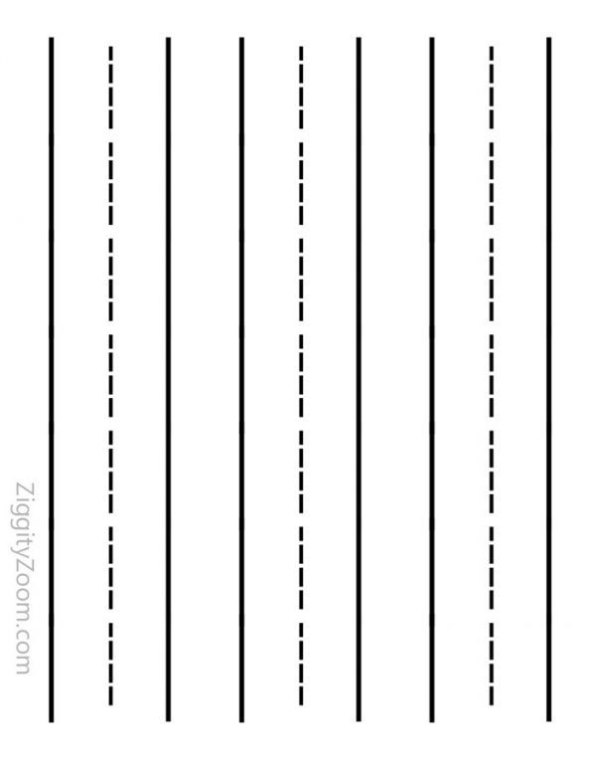**Indicator #11 - Stages of Writing**

**Student demonstrates age-appropriate writing skills including writing letter-like shapes or letters, writing most letters of name or using some spacing and punctuation.**

Assess also based on journals.

Write/ trace/copy:: ’My name is *(student’s name)*’.

**NOTEs (Include ‘Journal entry used’, ‘Copy’, ‘oral receptive’)**

|  |
| --- |
|  |
|  |
|  |
|  |



**NOTEs (Include ‘Journal entry used’, ‘Copy’, ‘oral receptive’)**

|  |
| --- |
|  |
|  |
|  |
|  |



**NOTEs (Include ‘Journal entry used’, ‘Copy’, ‘oral receptive’)**

|  |
| --- |
|  |
|  |
|  |
|  |

**Indicator #17 – Counting**

**Student knows number names.**

Rote counting

|  |  |  |
| --- | --- | --- |
| 1-10 | 10-20 | 20+  MAX: ___ ___ ___ ___ |

**Indicator #18 - Naming Numbers**

**Student knows number names**

|  |  |  |  |
| --- | --- | --- | --- |
| 7 | 11 | 2 | 6 |
| 16 | 4 | 18 | 13 |
| 9 | 1 | 12 | 20 |
| 15 | 14 | 8 | 19 |
| 5 | 17 | 10 | 3 |

**Indicator #19 - Operations & Algebraic Thinking**

**Student understands addition as putting together and understands subtraction as taking apart.**

Use manipulatives to complete the following math problems:

|  |  |
| --- | --- |
| 7-4 | 3+5 |
| 5+2 | 8-4 |
| 1+6 | 6-2 |

**Indicator #20 - Identifying Shapes**

**Student identifies shapes.**

|  |  |  |
| --- | --- | --- |
|  |  |  |
|  |  |  |
|  |  |  |

|  |  |  |
| --- | --- | --- |
|  |  |  |
|  |  |  |

**Indicator #21 - Positional Words**

**Student shows understanding of the relative position of objects.**

The teacher places a manipulative relative to another object and the student names its order/ position.

Modify: The teacher gives the relative position, & the student follows directions.

|  |  |  |
| --- | --- | --- |
| under | beside | last |
| on top | first |  |

**NOTEs: (If the Modify option is used, it should be mentioned here along with a description of the results)**

|  |
| --- |
|  |
|  |
|  |
|  |

**Indicator #22 – Measurement**

**Student uses measurable attributes to compare objects.**

Students will measure four of the flowers with counting cubes and put them in height order.

**NOTEs: (If the Modify approach is used, it should be mentioned here, along with a description of the results)**

|  |
| --- |
|  |
|  |
|  |
|  |

**Indicator #23 – Data**

**Student classifies, counts and compares quantities**

The Teacher illustrates the student’s work using sorting mats.

The teacher will collect a mixture of ten large/ small and red/blue manipulatives. The student will sort in several ways based on size and color and describe results using “more of/ less of.” This includes 3 options:

1. Sort up to 10 objects by one attribute (size or color)
2. Sort up to 10 objects by one attribute and determine which category has ‘more or less’ of the attribute.
3. Sort up to 10 objects by two attributes and describe results of more or less.

Modify: The student will sort based on color and describe the results.

**Student Sorting Mat** – use this mat for all options including the MODIFY approach.

**This page must be printed prior to starting the assessment.**

|  |  |
| --- | --- |
|  |  |

**NOTEs**: **(Include the description of which attribute was used, the results of each option and/or if the Modify approach is used)**

|  |
| --- |
|  |
|  |
|  |
|  |

**Indicator #29 - Control & Coordination- Fine Motor**

**Student demonstrates coordination, strength, strength and muscle control when manipulating small objects or tools.**

The student will demonstrate their cutting skills using a strip of paper. The teacher will attach the cutting practice below.

Modify: The teacher will observe the student explore and manipulate smaller objects using hands, fingers, and wrists.

**NOTEs: (If the Modify approach is used, it should be mentioned here, along with a description of the results)**

|  |
| --- |
|  |
|  |
|  |
|  |

**Intentionally blank for student work**

**Indicator #30 - Control and Coordination- Gross Motor**

**Student demonstrates coordination of body movements.**

Assess based on observations: Student demonstrates coordination of body movements.

**NOTEs**: **(Include the description of which attribute was used, the results of each option and/or if the Modify approach is used)**

|  |
| --- |
|  |
|  |
|  |
|  |

**Resources:**

**Additional resources must be accessed from the following links. Do not copy.**

1. Flower Heights: <https://stayathomeeducator.com/free-flower-height-measurement-printable-for-preschoolers/>
2. Cutting strips: <https://fun-a-day.com/spring-cutting-strips/>
3. 3D shape links: <https://etc.usf.edu/clipart/41600/41699/fc_cone_41699.htm>
4. <https://etc.usf.edu/clipart/41700/41749/fc_sphere_41749.htm>
5. <https://etc.usf.edu/clipart/43100/43150/prism-quad20_43150.htm>